**SPRINT BACKLOG REFINEMENT**



**Date:24/02/2017**

Contents

I. BACKLOG ESTIMATE EVIDENCES 3

1. REGISTER NEW ACCOUNT 3

2. VISITOR LOG IN 4

3. VINASWAP MEMBER LOG OUT 4

4. VISITOR SEARCH SITE INFORMATION 5

5. VISITOR VIEW SITE MAINPAGE 5

6. MEMBER CREATE PROFILE 6

7. MEMBER EDIT PROFILE 6

8. MEMBER VIEW PROFILE PAGE 7

# BACKLOG ESTIMATE EVIDENCES

## REGISTER NEW ACCOUNT

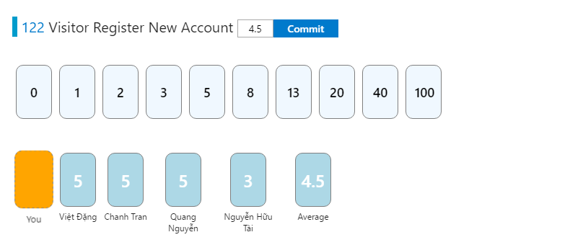

* So the story points of Register New Account: 5

## VISITOR LOG IN

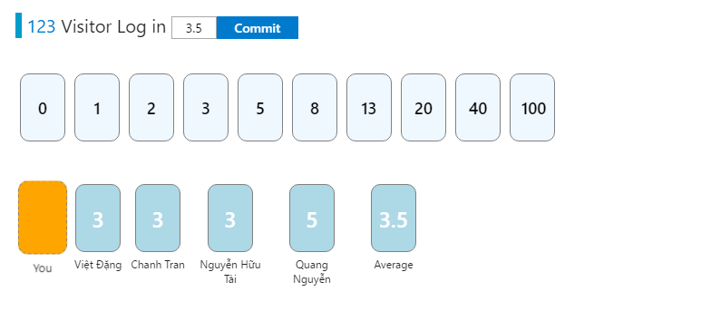

* So the story points of Visitor Log In:3

## VINASWAP MEMBER LOG OUT

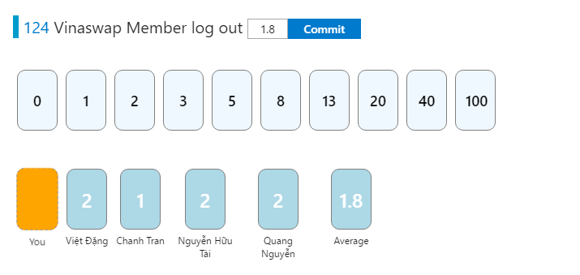

* So the story points of Vinaswap Member log out : 2

## VISITOR SEARCH SITE INFORMATION

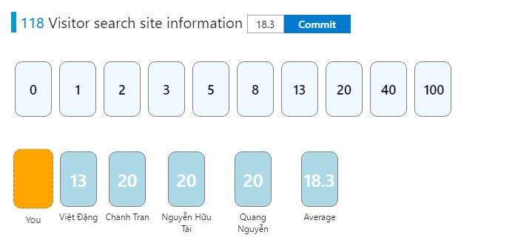

* So the story points of Visitor search site information : 20

## VISITOR VIEW SITE MAINPAGE

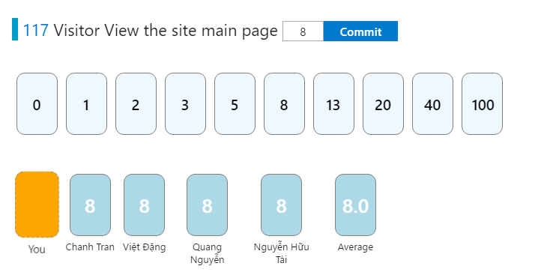

* So the story points of Visitor View the site main page:8

## MEMBER CREATE PROFILE

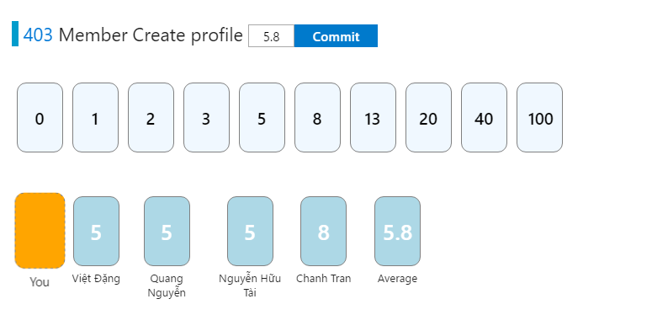

* So the story points of Member Create profile: 5

## MEMBER EDIT PROFILE

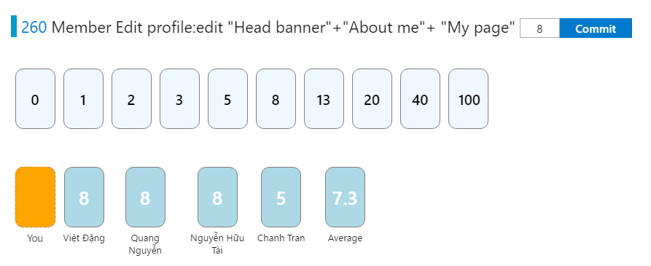

* So the story points of Member edit profile:8

## MEMBER VIEW PROFILE PAGE

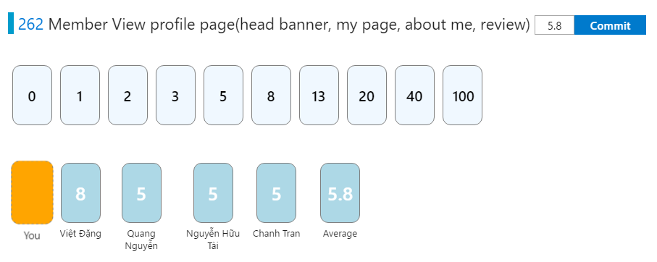

* So the story points of Member view profile page:5